Experimental study to assess the nature of the lime-bentonite- mechanism of reaction.
Fatima Gueridi1,2, Zohra Derriche2
¹ University of Algiers 1, Benyoucef Benkhedda, Rue Didouche Mourad, Algiers Algeria
² (LTPiTE) Research Laboratory. Ecole Nationale Supérieure des Travaux Publics, Kouba Algiers, (ENSTP).
f.gueridi@univ-alger.dz https://orcid.org/0000-0001-6956-0776
Abstract. Lime soils treatment has been successfully applied in construction practices for many decades. Despite numerous investigations aiming to understand the clay-lime reaction, the mechanisms responsible for the observed changes remain until today not conclusively elucidated. This study contributes to uncovering the mechanisms underlying the clay-lime reaction. The experimental program involved treating bentonite samples with lime and other chemical reagents (calcium and barium chlorides, and sodium hydroxide) assumed to behave similarly to lime, and observing the effects of these treatments on plasticity, soil grain-size distribution (GSD), and strength. A conventional dispersing agent was used to assess the durability of changes induced in GSD.
The results reveal that all additives tested reduced the liquid limit, but lime was the only additive that increased the plastic limit of the treated bentonite. GSD results indicate the flocculation of fine bentonite particles into clusters, with cluster size increasing over curing time. Clusters formed by lime treatment remained relatively stable, whereas those formed by other reagents disintegrated upon contact with the dispersant. Additionally, only lime promoted strength development in the treated samples.
These observations suggest that the clay-lime reaction is an irreversible chemical process yielding pozzolanic reaction products that bind bentonite particles. In contrast, reactions with other reagents are reversible physico-chemical processes. The findings of this study suggest that clay-lime treatment may enhance the erosion resistance of soils.
Keywords: Bentonite-lime reaction, Texture, Flocculation, Pozzolanic, Strength.
- Introduction

Among the traditional chemical additives used for stabilization of soils, lime is by far the most common one owing to its economy and effectiveness (Muhmed, Abdelrahman 2022). The characteristics of soils treated with lime undergo remarkable modifications upon lime treatment, in particular on plasticity, swelling capacity, grain size and strength (Firoozi et al. 2017; Eades and Grim 1960). Due to its low cost, positive effects, and practical construction simplicity, lime has been the subject of several investigations that allowed to shed some light on the clay-lime real mechanisms (Zhang et al. 2023). Improvements brought about by lime treatment are well established to proceed as short-term modifications that show quasi-instantaneously on soil texture and as long-term reaction that manifests itself on strength development. According to literature, the changes are attributed in the short term to lime hydration, adsorption and cationic exchange between the calcium of the lime and the other cations present in the soil as well as to the flocculation of fine soil particles (Firoozi et al. 2017 ; Maubec 2019). Due to this flocculation; the lime-treated clays exhibit a different grain size distribution (KumarS et al.2019). In the long term, changes are attributed to the pozzolanic reaction (Firoozi et al. 2017; Eades and Grim 1960) which takes place between calcium of lime and clay minerals to yield calcium hydrated silicates and aluminates (CSH, CAH) as cementitious products which are responsible for long term strength development (Firoozi et al. 2017 ; Maubec 2010) ; KumarS et al. 2019). Despite the numerous investigations devoted to the issue, the clay-lime reaction is until today not fully elucidated and the mechanisms underlying it are not conclusively understood (Shahzada and Aadil 2020).
The present work attempts to gain some understanding on the nature of the clay-lime reaction by observing the improvements that occur on plasticity, grain size distribution (GSD) and strength evolution and focusing on the durability of these improvements. For checking the durability of the modifications to the GSD, the tests are carried out with and without dispersant, which makes it possible to distinguish the natural and electrolyte flocculation from the chemical flocculation produced by lime action.
- Materials & Methods
Bentonite: The bentonite used comes from Maghnia (in western Algeria). It is a sodic bentonite, whitish in color. Chemical composition of the used bentonite are summarized in table 1. The main constituents are silica and alumina which constitute the structure of clays.
Table 1. Chemical characteristic of used bentonite
Element | % | Element | %
SiO₂ | 64.48 | SO₃ | 0.09
Al₂O₃ | 17.77 | Na₂O | 3.06
Fe₂O₃ | 2.02 | MgO | 3.13
CaO | 1.62 | TiO₂ | 0.12
K₂O | 1.73 | P₂O₅ | 0.03
LOI | 5.9 | - | -
The XRD spectrum, presented in figure 1, indicates montmorillonite as the predominant clay mineral and also reveals the presence of quartz, calcite Cristobalite and potassium feldspar (Orthoclase – O) ( Gueridi and Derriche 2021).
The pH of bentonite is 10.5. Optimum Proctor conditions are 35% for moisture content and 1.2 for dry density. Total specific surface is equal to 778 m²/g
Lime: It is a commercial quick lime, marketed in bags of 25 kg. It comes from the region of Saida (Western Algeria) in a form of a fine white powder, It contains 93% of particles having a dimension less than 200µ.

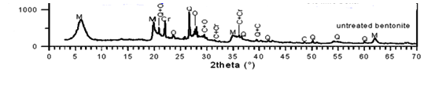
Fig.1 Bentonite Diffraction-X-Ray
Reagents used: are pure chemicals that come in a fine crystal form (calcium chloride, barium chloride dihydrate, sodium hydroxide) and a dispersant (sodium hexametaphosphate). Main characteristics of the used reagents are summarized in table n° 2.

Tableau 2: Used stabilizers characteristics
Stabilizer | molar Masse (g) | Solubility (20°) g/l | Form | CaO equivalent masse(g)
CaO | 56 | 1.5 | fine Powder | 1
CaCl₂ | 110.99 | 745 | Cristal | 1.98
BaCl_{2.}2H₂O | 244.28 | 360 | Cristal | 4.36
NaOH | 40 | 851.9 | Cristal | 0.71
The tests carried out comprise:
Consistency limits of bentonite and bentonite-additives specimens. Dry mixed clay-additive samples are hydrated with distilled water, mixed until brought to paste state, are covered and kept 24 hours before plasticity testing. The test is performed according to the ASTM D4318-00 Standard.
Grain size distribution: (sedimentation part) of the bentonite and the reagent-treated bentonite samples were performed according to the ASTM D422-63 Standard, using sodium hexametaphosphate as a dispersing agent. Tests were performed on 5% lime-treated clays (with and without dispersant). Some tests are carried out on purpose without the dispersant.
Unconfined compressive strength (UCS). Compression testing was performed according to ASTM D 5102 – 96 (1996).
Reagent-bentonite mixtures required to obtain 1.2 dry density samples were prepared by first adding the quantity of dry reagent (5 % of lime or molar mass reagent-lime equivalent) to the bentonite and mixing vigorously until the mixture was homogeneous. 5% lime content is retained as the smallest percentage that gives the highest pH-value (12.4) of the lime-bentonite mixture (Eades and Grim 1960). The samples were statically compacted (at OPN conditions) in a 70/35 cm molds and stored carefully at laboratory room temperature (23-25°C) for different curing periods; 1-5 hours, 1, 3, 7, 14, 28, and 60 days for most of the samples.
- Results and analysis
  - Plasticity changes with additives
Figure 2 shows the results of consistency limits of additive-bentonite samples. We note that the liquid limit (figure 2a) decreases with increasing contents of all the additives used; lime, CaCl₂, BaCl₂ and NaOH with different magnitudes though. However, lime has been found as the least effective at reducing liquid limit relatively to the other additives. Both calcium and barium chlorides used exert the same effect on the liquid limit of the clay; a small amount of theses additives (0.5%) is sufficient to reduce drastically the liquid limit and increasing additive above this limit has no further effect on the liquid limit.
The results presented in figure 2b show that lime is the only additive that increases plastic limit. Plastic limit decreases slightly with calcium and barium chlorides and seems not to be affected by sodium hydroxide content increase. It appears that plastic limit increases with lime content up to about 5% beyond which no more changes on the limit seem to occur. This lime content is called lime fixation point Hilt and Davidson1960) ; Zhang et al. (2023) confirmed these results.
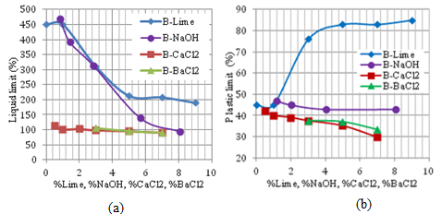
a) Liquid limit b) Plastic limit
Fig. 2 Atterberg limits variation of reagent treated bentonite

  - Grain-Size Distribution changes
    - Effect of lime on GSD
The data presented in figure 3 show the GSD curves results. The Figure 3a shows the pure bentonite curves measured with (WD) and without dispersant (ND). The difference between the 2 curves expresses the natural flocculation of the bentonite fines. Nevertheless, the ND bentonite curve exhibits bigger size elements.
In the same figure 3a we present the 5% lime-treated bentonite GSD curves measured without dispersant (ND) after 3, 7 and 28 days of curing times. These curves locate underneath the untreated bentonite curves and move to the left indicating important reduction in fine particles, showing strong flocculation.
Figure 3b shows the GSD curves of untreated and 5% lime treated bentonite measured at different curing times at 3, 7, 28 and 90 days, with dispersant (WD). As the same way as without dispersant, the curves indicate the transformations that take place on the GSD of the bentonite with the progress of the clay-lime reaction (Benmisra 2013).
Flocculation measured in the ND conditions is however greater than that obtained with (WD). Let us call it total flocculation (natural + lime provoked flocculations).
The literature explains this result by the phenomenon of flocculation caused by the calcium of the lime (Verhasselt 1990) ; Osula 1996). The reduction of fine elements is particularly significant from 7 days of treatment and continues up to 90 days. As evidenced by the further progress in time of the GSD evolution and the continuous grain-size increase of the cured lime treated samples, the cementing material seems to continue to form and to bind several clusters together to yield bigger-size elements with the clay-lime reaction advancement. GSD curves of figure 3 indicate that the median size diameter (D50) increases from smaller than 1μm for the untreated clay to 2μm after 3 days to 3μm after 7 days to 20μm after 28 days and reaches more than 100μm after 90 days of curing time. However, we notice that the percentage of fine elements in WD conditions, has increased compared to that obtained without dispersant (ND). Which suggests that the dispersant cancels a part of the flocculation achieved.
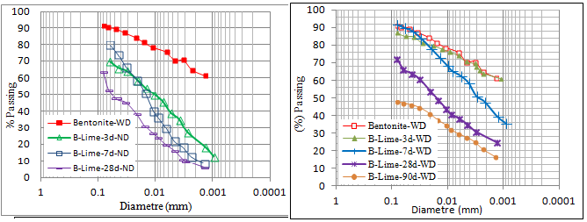
a): B-5%lime(without dispersant) b): B-5%lime (with dispersant)
Fig.3 Evolution of lime treated Bentonite GSD with curing time
In order to highlight more this result, we present in Figure 4, a zoom of the ND and WD grain size distribution curves of the 5% lime treated bentonite at 28 days curing. It appears from these curves that the addition of lime to the bentonite brings a total flocculation whose importance can be estimated by the surface between the bentonite-WD curves and the 5% lime treated bentonite-ND curves. Two parts of flocculation are evidenced by the use of dispersant. One is reversible it concerns the organization in flocs which is reversible and disappears by the action of a dispersant because it is ionic in nature. The other part of flocculation is irreversible and called granulation. Granulation is of a chemical nature. It involves a phenomenon of cementation of the flocculated particles (Verhasselt 1990). The hatched surface illustrates that part of the irreversible flocculation which is not cancelled out by the dispersant and which continues to increase with curing time.
    - Effect of other reagents on GSD
Results of figure 5 show that compared to lime curve, GSD-ND curve of CaCl₂, exhibits a stronger flocculation effect of the particle size of the bentonite while almost no flocculation appears on the GSD-WD curve. Under the WD conditions, the curves show GSD curves which are very close to that of the untreated bentonite sample. The flocculation achieved by CaCl₂ addition is cancelled out by the dispersant action and does not seem to proceed with time as well.
The results obtained with barium chloride, not presented in this work, are similar to those of calcium chloride.
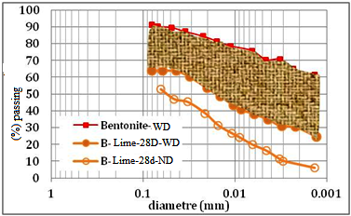 | 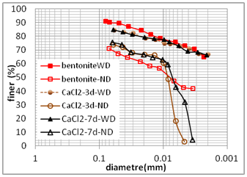
Fig.4 Hatched area showing the part of maintained flocculation |  | Fig.5 Evolution of CaCl₂ GSD of treated Bentonite (WD) and (ND) for 3- and 7-days curing times

  - Unconfined strength evolution with additives
In figure 6, we gather the curves of the unconfined compressive strength of the pure bentonite and 5% reagents treated bentonite. We can clearly see the important effect of lime on the development of strength. From the first days, the strength records a more or less significant gain which would be due to the granulation of the bentonite particles. Comparable results have been presented by Muhmed, Abdelrahman (2022) who studied strength evolution of 7% lime treated bentonite and concluded that the immediate increase in strength reflects immediate changes in the clay properties due to fast interaction between lime and clay particles in the presence of water.
We note the strength of lime treated bentonite increases with time and reaches values of more than 4 times that of pure bentonite which is explained by the development of the calcium silica hydrate and calcium alumina hydrate (CSH and CAH). Muhmedand Abdelrahman (2022) obtained a strength gain of 346% within 28 days compared to the untreated clay. This improvement was attributed to the filling of enormous part of the voids by the pozzolanic activity of lime (Muhmed and Abdelrahman 2022).
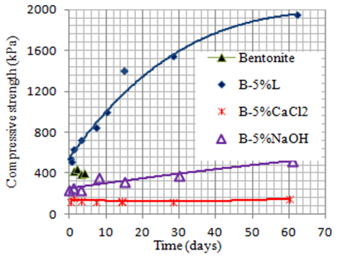
For samples treated with calcium chloride CaCl₂ and sodium hydroxide NaOH at the same conditions, results that these additives do not produce any noticeable strength development. Neither NaOH hydroxyls nor CaCl₂ calcium could improve the strength of bentonite.
Fig.6 Evolution of lime and reagent treated bentonite strength with curing time
- Discussion
The results obtained in this study lead to highlighting some observations regarding the characteristics tested. The decrease in the liquid limit is the result of flocculation of the clay particles induced by the added electrolytes (Van Ophen 1987). The added electrolytes (lime, CaCl₂, BaCl₂ and NaOH) shrink the diffused double layer of the clay particles which can reorganize in bigger-size elements so increasing the grain size and reducing the specific surface of the mixture. In the process of cation exchange, bivalent calcium ions of lime replace monovalent cations within the clay. Calcium ions link the soil particles that have negative charge together, thereby decreasing the repulsive forces and reducing the thickness of the diffused water layer (Kumar et al. 2019).
The decrease of liquid limit expresses an increase of the size of the soil elements that form as a result of the flocculation of clay particles induced by the additives that act as ( Osula 1996) . The lime being the only additive that increases plastic limit means that unlike the other reagents the lime clusters organize in an open face-to-edge like structure that retains water molecules within its tiny voids. The cluster formation is moreover confirmed by the GSD curves results which clearly show reduction of fine particles and formation of bigger-size elements caused by calcium of the lime (Osula 1996). The other reagent clusters seem to organize in a compact and dense structure compatible with the decrease of the plastic limit results.
The GSD curves obtained with the dispersing agent revealed however that a part of the lime-bentonite formed clusters remained stable indicating that stable clusters are formed by a lime-bentonite reaction product that binds the bentonite particles together durably within the cluster. It has been found moreover that the lime-bentonite cluster size increases with curing time (Maubec 2010 ; Gueridi et Derriche 2021). This pozzolanic reaction should proceed probably until lime is entirely consumed. On the other hand, reagent-bentonite formed ones cancelled out entirely when put in solution with a dispersing agent. The bentonite clusters that form with the other reagents should be the result of a reversible ionic action as they cannot resist the dispersing effect.
Strength development observed in this study demonstrates that lime bentonite pozzolanic reaction proceeds with corroborating the time evolution of cluster size observed on the measured GSD curves. This is explained by the formation of CSH and CAH which harden and produce more durability (Ahmadullah and Chrysochoou 2024).
Additive-bentonite clusters that form with the other reagents should be the result of a reversible ionic action as they cannot resist the dispersing effect. The stability change in the texture of lime bentonite treated and the development of its strength suggest the possibility of using lime to increase the soil erosion resistance (Aqel, Attom et al. (2024).
- Conclusions
The lime-treated bentonite underwent significant textural changes. The increase of plastic limit upon lime treatment results from initial flocculation followed immediately by cementation of the clay particles within the clusters to form resilient cluster elements. This cluster stability does not show with CaCl₂ or NaOH treatments indicating for both these electrolytes the complete disintegration of the clusters formed by ionic flocculation and they produce no gain in strength. The particle size analysis in its sedimentation part with and without dispersant showed that a part of the flocculation due to lime is irreversible. Lime increases the bentonite strength with time which seems to stem from a gradual cementing clay-lime reaction material probably CSH and CAH that bind durably the flocculated clay fine particles into the clusters formed. The changes in the texture of lime bentonite treated and the development of its strength suggest the possibility of using lime to increase soil erosion. This application is among the many solutions offered by lime soil treatment to the problems posed by poor soils and the landfills they produce as well as to the protection of the environment and the saving of non-renewable materials.

References

- Ahmadullah T, Chrysochoou, M (2024) Relationship between strength development and pozzolanic reactions in lime stabilized kaolinite. Geo-Engineering,15(11) https://doi.org/10.1186/s40703-024-00212-6.
- Aqel R, Attom M, El-Emam M, Yamin M (2024) Piping Stabilization of Clay Soil Using Lime. Geosciences 14(5):122. https://doi.org/10.3390/geosciences14050122.
- ASTM D 5102 – 96 (1996) Standard Test Methods for unconfined compressive strength of compacted soil-lime mixtures.
- ASTM D422-63 (1996) Standard Test Method for Particle Analysis of Soils. ASTM D 5102 – 96.
- ASTM D4318-00 Standard Test Methods for Liquid Limit, Plastic Limit and Plasticity Index of Soils.
- Benmisra F.Z, (2013) Analyse géotechnique de la réaction sol-chaux. Mémoire de magistère. ENSTP, Alger.
- Eades JE, Grim RE (1960) Reactions of hydrated lime with pure clay minerals in soil stabilization. Highway Research Board Bulletin 262:51-63.
- Firoozi AA, Guney Olgun C, Firoozi AA et al. (2017) Fundamentals of soil stabilization. Geo-Engineering 8(26) https://doi.org/10.1186/s40703-017-0064-9Little
- Gueridi F, Derriche Z (2021). Strength development and lime consumption progress relationship in lime stabilized bentonite samples. Bull Eng Geol Environ 80, 5505–5514 https://doi.org/10.1007/s10064-021-02262-x.
- Hilt GH, Davidson DT (1960) Lime fixation in clayey soils. Highway Research Board Bulletin, 262 : 20-32.
- Kumar S et al. (2019) Effect of Lime (Content &Duration) on Strength of Cohesive Soil. Int. Res. J. of Eng.and Tech, 6(5):198-205.
- Maubec N (2019) Approche Multi-Echelle du traitement des sols à la chaux : Etude des interactions avec les argiles. Thèse Doctorat. Université de Nantes, (2010).
- Muhmed A, Abdelrahman S (2022) Effects of curing time and temperature on the unconfined compressive strength of lime-treated expansive clay. The 9th National Conference on Building Materials and Structural Engineerig. NCBMSE, (At: Tripoli – Libya).
- Osula DOA (1996) A comparative evaluation of cement and lime modification of laterite. Engineering Geology 42(1): 71-81. https://doi.org/10.1016/0013-7952(95)00067-4
- Shahzada OM, Aadil (2020) Stabilization of Soils with Lime. A Review. J. Mater. Environ. Sci.11( 9):1538-1551. ISSN : 2028-2508.
- Van Olphen H, (1987) Dispersion and flocculation. Chemistry of clay minerals. Mineralogical Society Monograph 6:203-224 Longman Scientific & Technical, Newman A.C.D. (ed) London.
- Verhasselt AF, (1990) The nature of the immediate reaction of lime in treating soils for road construction, Physico-chemichal aspects of and related materials. ASTM, Philadelphia, 7-17.
- Zhang J, Hai L, Peng J, Zhang Z (2023) Effects of Lime Content on Road Performance of Low Liquid Limit Clay. Applied Sciences 13(14):8377. DOI: 10.3390/app13148377

